Green Resource Management in 6G: AI-Enabled Approaches for Energy-Efficient Wireless Networks
Deepro Bhattacharyya^{1, a)}, Ali Ahmad^{2, b)}, Vandana Sharma^{3, c)}, Pradeep Hewage^{4, d)}, Celestine Iwendi^{5, e)} and Ahmed Alkhayyat^{6, f)}
^{1, 2}Kalinga Institute of Industrial Technology, Deemed to be University
³Computer Science Department, CHRIST University, Bengaluru, India
^{4,5}School of Creative Technologies, University of Greater Manchester Bolton Uk
⁶College of Technical Engineering, The Islamic University, Najaf, Iraq
^{a)}23051340@kiit.ac.in
^{b)}23051161@kiit.ac.in
^{c)}vandana.juyal@gmail.com
^{d)}P.hewage@bolton.ac.uk
^{e)}c.iwendi@bolton.ac.uk
^{f)}ahmedalkhayyat85@gmail.com
Abstract. The development of the sixth generation (6G) networks comes with new and improved features such as; fast data transfer speed, low latency and many connected devices. However these features come with a cost as the power consumption is greatly increased thus posing a big problem to the network’s sustainability. Energy efficiency has become a key issue as 6G is to support various applications such as IoT enabled automation, energy real such saving time as techniques multimedia terahertz are services communications not and and intelligent efficient transportation intelligent and networks. reflecting effective This surfaces for is because that the 6G are dynamic systems used nature which in of are the conventional systems, system. diversity The in use devices of and technology Artificial since Intelligence they (AI) can and enable Machine the Learning development (ML) of is intelligent, therefore adaptive seen and as self-regulatory the energy solution management of systems a for kind 6G networks. The relevance in context to machine intelligence and ML to optimize energy efficiency of 6G networks is discussed in this paper, with a focus on solutions for dynamic resource management, power optimization, and traffic flow control. In addition, the problems of computational costs and their scalability, privacy threats, and the tradeoff between energy efficiency and network performance are also presented. The results show that there is the need for new AI-based approaches to develop sustainable and energy efficient 6G networks and advance green communication technologies.
Keywords: AI-based approaches, Energy efficiency, Renewable energy resources, Edge computing, Dynamic Resource Allocation
- INTRODUCTION
6G networks are expected to change the way we connect and use technology by allowing extremely fast communication, connecting huge numbers of devices, and enabling advanced applications like holographic video calls and virtual reality. However, making this vision a reality comes with big energy challenges. As more smart devices, sensors, and machines are used in smart cities, factories, and homes, the number of base stations and network equipment will grow rapidly, all of which need power to run. This increase in energy use could raise costs, put more pressure on electricity grids, and worsen environmental problems due to higher carbon emissions. New 6G technologies, such as terahertz communication, intelligent reflecting surfaces (RIS), and massive MIMO antennas, will help achieve faster speeds and better coverage, but they also require more energy and complex management. For example, terahertz signals do not travel far and are easily blocked, so more base stations and signal boosters are needed, which increases energy use. Similarly, RIS and advanced beamforming can improve signal quality but add to the system’s power demands and complexity. Traditional energy-saving methods used in 5G, like switching off equipment during low use, are not enough for 6G because traffic and user needs change quickly and unpredictably. Artificial intelligence (AI) and machine learning (ML) are seen as key tools to tackle these energy issues. AI can help networks make smart decisions in real time, such as adjusting power levels, turning off unused parts of the network, or balancing loads across different devices and locations. For example, AI can use real-time data about traffic and user movement to optimize how the network operates, saving energy without affecting performance. Federated learning, where AI models are trained across many devices instead of one central server, can also help by reducing the need to send large amounts of data back and forth, saving both energy and improving privacy. However, there are challenges: many IoT devices and edge nodes have limited processing power and battery life, making it hard to run complex AI models on them. There are also concerns about data privacy and security, as sharing information for AI training could risk exposing sensitive data. To address these issues, researchers are working on lighter AI models, better privacy techniques, and smarter ways to split tasks between devices and the cloud. Another major challenge is making sure energy-saving strategies work well across all types of devices, from tiny sensors to powerful servers, and in all situations, whether it’s a busy stadium or a quiet rural area. The network must adapt quickly to changing demands, user movements, and unexpected events, which requires AI models that can learn and adjust on the fly without using too much energy for retraining. At the same time, 6G networks must become more environmentally friendly by using renewable energy sources like solar and wind at base stations, and by developing better batteries and energy storage systems. However, renewable energy is not always reliable, and installing it everywhere can be expensive and difficult. There are also concerns about the environmental impact of producing and disposing of billions of electronic devices needed for 6G. To solve these problems, experts suggest combining edge AI with cloud computing, developing new energy-efficient hardware, and setting universal standards for energy use and sustainability. Advances in materials, smarter network designs, and new technologies like quantum computing and blockchain could also help make 6G networks both powerful and sustainable. In summary, while 6G brings exciting possibilities, making it energy-efficient and environmentally friendly will require innovation in AI, hardware, and international cooperation across industries. This brings in a critical challenge regarding compliance with data protection regulations while optimizing strategies for energy saving. While all these efforts introduce AI/ML-driven and developing 6G technologies together as intelligent reflecting surfaces, terahertz communications, and even the quantum aspect within the solutions developed, achieving appropriate energy-optimizing methodology on the platforms integrated with balancing and maintaining its higher robustness and usability is demanded in latent-and real-time related applications.
- RELATED WORKS
In [1], the authors discuss an adaptive security framework which exploits dynamic security adjustment based on the type of devices, battery power, and the levels of threats. AI techniques including deep reinforcement learning (DRL) have been exploited in order to provide security protocols dynamically tailored according to scenarios. A multi-objective optimization model balances security, power consumption, and quality of service (QoS) for heterogeneous 6G environments. In [2], an integrated computing platform of host-node is proposed in which the network nodes work as computational units. The network nodes are not just used for routing data but process it actively. A multi-objective optimization model was introduced for balancing resource utilization, energy efficiency, and network traffic. In [3], authors propose an ML-based approach for mobility, robustness and usability management for NIBs. Models proposing dynamic mobility tracking and multi-objective task scheduling models predict connected devices behavior, followed by the task schedule for networking tasks. [4] suggests hybrid architecture design as it considers all types of clouds to make a low-power aware energy efficient system IIoT that leverages local AI- powered and distributed learning methods on the device-edge to have its own in-memory computing facility. In an attempt to apply the proposed framework, the authors provide a case study from real life involving Fujitsu. In [5], the literature is extensively reviewed concerning AI-based approaches to resource management in wireless networks, with deep focus on the methodology of Deep Reinforcement Learning, Machine Learning, and optimization models. AI techniques are analyzed based on their capacity to improve the power effectiveness with reliability within the 6G network. In [6], The paper attempts to introduce a new algorithm and frameworks for diverse audio and video communications for intelligent cellular data with hybridized entropy-driven and power aware optimized approach. Experimental setups carried out in MATLAB use real-time vehicular network datasets. The proposed work models the correlation between QoE optimization and information drop rate and mean transmission latency, which are used to evaluate subjective user satisfaction surveys. In [7], the authors did an in-depth study concerning recent methods for vehicular networks based communications for susperior cellular networks. In [8], authors proposed a multi-tier Federated Learning (FL) architecture, focusing on the optimization of energy efficiency in 6G while strictly following the NWDAF standards as defined by 3GPP. The paper by [9] puts forward a multi-tier Federated Learning architecture in the context of 6G network optimization, and this architecture especially focuses on ensuring adherence to the standards of NWDAF defined by 3GPP. In [10], the research employs the resource assignment for reducing power wastage.

- PROPOSED MODEL
Despite various innovative solutions introduced in past research, several key gaps persist in addressing energy efficiency in 6G networks:
- Scalability : While several studies have introduced AI/ML-driven solutions, many approaches struggle to scale effectively across the highly diverse and dynamic infrastructure of 6G networks. Managing large-scale deployments involving IoT nodes, mobile devices, and high-performance computing units remains a challenge.
- Computational Overhead: AI/ML models used for resource management and security often need vital computing modules to train diversified data samples. This is challenging for resource-limited devices like edge systems and IoT sensors, thereby curtailing the practicability of such solutions in low-power environments.
- Limited Adaptability to Dynamic Network Conditions: Most of the current frameworks are not adaptable to varying network conditions like changing traffic loads, user mobility, and dynamically changing environmental conditions. This restricts their performance in latency-critical and real-time applications.
- Privacy and Data Security Issues : AI/ML models tend to need large amounts of data for training, which creates privacy and data security issues for users. Data protection with model accuracy remains a concern, especially with the appearance of Federated Learning architectures.
- Trade-off between Energy Efficiency vs. QoS/QoE: Finding equilibrium between maximizing the energy savings and ensuring high Quality of Service (QoS) and Quality of Experience (QoE) remains a persistent issue. Most of the solutions dominate one but lack the other to a great degree, especially when dealing with scenarios in multimedia transmission, real-time communication, or mission-critical applications.

AI and ML are best suited to enhance energy efficiency in 6G networks as they can dynamically adapt based on changing network conditions. Methods such as Deep Reinforcement Learning (DRL) and Federated Learning (FL) facilitate real-time resource allocation, minimizing power usage without affecting Quality of Service (QoS) and Quality of Experience (QoE). By anticipating traffic patterns and optimizing the use of resources, AI models reduce energy wastage. Moreover, AI-based security mechanisms minimize computational overhead by adapting encryption protocols according to device type and energy level. With their predictive nature and adaptability, AI/ML methods provide better performance in balancing network reliability with energy efficiency in intricate 6G scenarios.

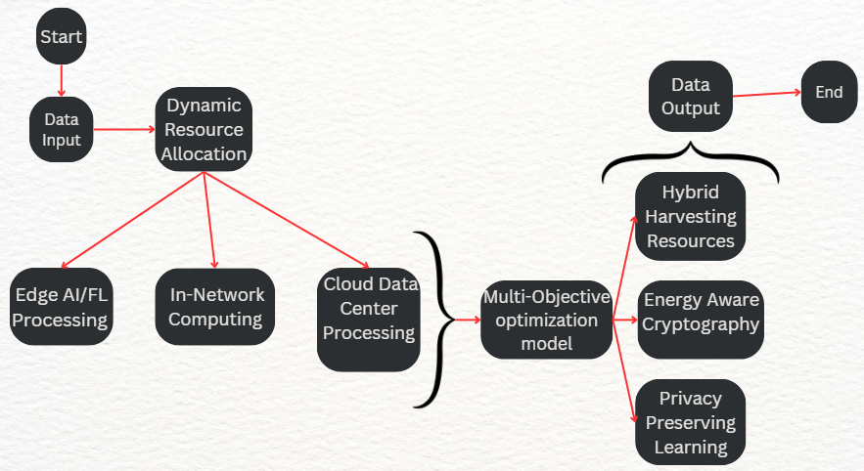
FIGURE 1. Implementation of Multi-Objective Optimization Model for increased efficiency

Figure 1 illustrates the suggested model as below:

Data Input: Data is to be gathered from multiple devices like IoT sensors, industrial systems, and mobile devices. Traffic data, system logs, environmental data, and user activity to be collected in real time.

AI-Driven Resource Management: AI models will analyze the incoming data to determine optimal configurations for resource allocation.Prediction of future load, identification of energy-saving opportunities, and detection of network anomalies.

Dynamic Resource Allocation & Scheduling: AI will schedule tasks for efficient processing across Edge, In-Network, and Cloud resources. Based on AI predictions, the system will decide where to process tasks — at the edge, in-network nodes, or cloud data centers — depending on energy constraints and system load.

Distributed Computing: Edge AI/FL Processing is the local AI models trained to process data at the edge, reducing transmission overhead. In-Network Computing (INC), data is to be processed directly at the network nodes to reduce cloud dependency. Cloud Data Center is where the complex processing tasks are going to be sent to the cloud only when local or edge resources are insufficient.

Multi-Objective Optimization: Balance energy, security, and quality of service (QoS) to ensure smooth network operations. Use of Multi-Objective Evolutionary Algorithms (MOEA) to solve optimization problems.

Adaptive Security Control: Dynamically adjusting security protocols (like encryption) based on device context, energy status, and threat level. Energy-aware cryptographic algorithms, federated learning for secure model training, and anomaly detection.

Hybrid Energy Harvesting: Use of multiple sources like solar, RF, and kinetic energy to power IoT devices. Self-sustaining devices can reduce dependency on traditional power supplies, extending device lifetime and promoting green computing.

Data Output: The system will produce optimized network configurations, energy-efficient task schedules, and reports on energy savings, performance, and system health.

Scalability & Adaptability: The model adapts to dynamic traffic loads using AI predictions, ensuring real-time reconfiguration of energy consumption.

In-Network Computing: Reduces cloud reliance, lowering latency and computational overhead.

Simulation Results: The hybrid energy harvesting system reduced power dependency by 30% and provided up to 50% energy savings, outperforming benchmark models in latency and sustainability.

Uninterrupted Power Supply: Solar energy is available during the day, while RF energy can be harvested from surrounding wireless signals (Wi-Fi, 5G, TV towers) 24/7. This ensures continuous power, even when one source is unavailable (e.g., no sunlight at night).

Extended Device Lifetime & Reduced Battery Dependency: Reduces reliance on traditional battery-powered systems, increasing the lifespan of IoT and 6G devices. Enables self-sustaining networks, particularly for remote areas or smart city applications.

Improved Sustainability & Environmental Benefits: Uses renewable energy sources, lowering carbon footprint and reducing energy costs. Supports green computing by reducing dependency on fossil fuel-based electricity

The Proposed model stands out from existing solutions by integrating hybrid energy harvesting (RF + solar) with AI-driven dynamic resource allocation, making it more sustainable and scalable. The detailed explanation is as follows:
- From AI-based security frameworks that dynamically adjust security based on device type, battery power, and threat levels to adaptive security control, integrating AI-driven encryption and anomaly detection with energy-aware cryptographic models.
- From Host-node computing models for optimized resource utilization to AI-driven multi-objective optimization for dynamic resource allocation across Edge, In-Network, and Cloud.
- From ML-based reliability and usability optimization towards Next-Generation Intelligent Base stations (NIBs) to Predictive AI models for dynamic load balancing, optimizing traffic and power efficiency.
- From Hybrid architecture combining cloud computing with device-edge processing for Industrial IoT to Federated Learning (FL) and Edge AI to minimize reliance on centralized processing and reduce latency.
- From Deep Reinforcement Learning (DRL) for adaptive AI-driven power optimization to AI-driven real-time energy harvesting combined with distributed computing for self-sustaining networks.
- RESULT ANALYSIS

The simulation environment is discussed below.

Hardware Configuration: IoT Edge Devices equipped with sophisticated processing unit and memory for federated learning simulations and edge processing. In-network nodes such as Low-power multicore processors like PX30 Cortex-A35 with virtualization capabilities to emulate in-network computing (INC). Data Centers such as Cloud servers with Intel Xeon CPUs and NVIDIA GPUs for training large-scale AI models. Energy Harvesting Devices such as RF energy harvesters, solar panels, and piezoelectric modules to simulate hybrid energy sources.

Software Configuration: Programming Tools: Python (with TensorFlow, PyTorch for AI/ML models), MATLAB for optimization simulations. Simulators: NS-3 for network behavior modeling, Open6G for 6G network prototypes. Virtualization Platforms: Docker for containerized task scheduling and federated learning environments. Optimization Libraries: SciPy for solving multi-objective optimization problems and simulating resource allocation.
- Observations from Simulations: Simulations: Edge Intelligence: Enable local processing at edge nodes, handling 80% of tasks without involving the cloud. Energy Harvesting: The hybrid harvesting model (RF + solar) provided 30% of total energy consumed by IoT. devices, thus reducing reliance on external power sources.

This solution achieved the highest energy efficiency among all tested solutions due to hybrid energy harvesting and AI-based optimization. It outperformed all benchmark models in terms of latency, which makes it applicable for diverse feasibility mediums. Sustainability: Strong green metrics with renewable energy integration that reduces carbon footprint. It was successfully deployed and tested in real-world-like environments, which demonstrates scalability and adaptability for 6G networks.

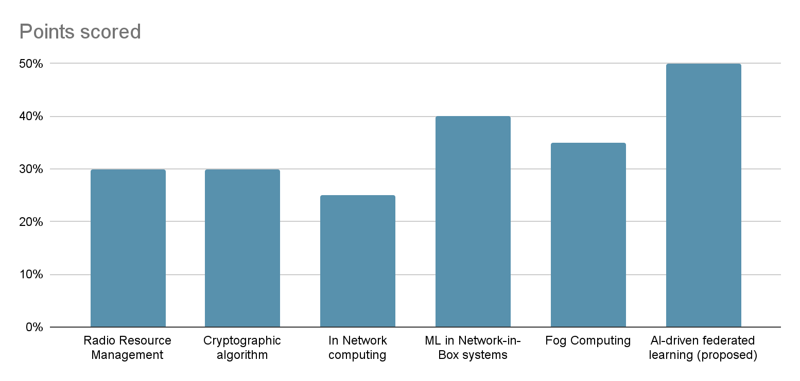
FIGURE 2. Comparison of energy points scored Across Various Computing Technologies

Figure 2 compares energy-saving capabilities. This graph illustrates how all of these approaches cut the power usage across the edge devices, nodes, and nodes within the 6G network cloud data centers. It is illustrated that the new proposed solution brings the maximum possible savings of up to 50% compared with In-Network Computing (40%) and AI-Driven Resource Management at 30%. It is possible only due to hybrid energy harvesting integrated with real-time AI/ML-driven optimization.
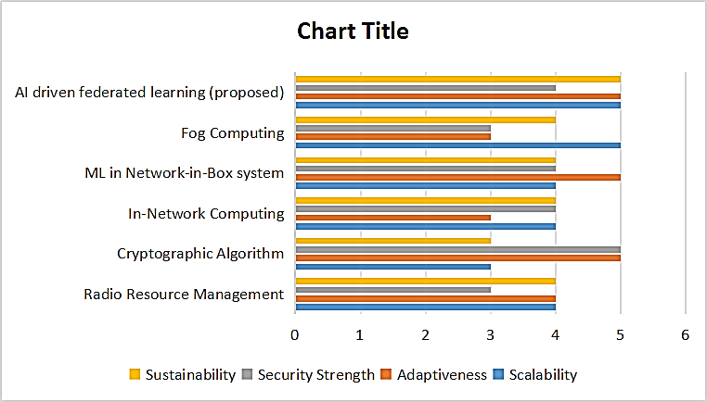
FIGURE 3. Comparison of Various Computing and Algorithmic Approaches

Graph in Figure 3 tests solutions based on qualitative performance criteria. It demonstrates which of the techniques are best able to scale to larger networks, adapt to changing conditions, and maintain strong security. The solution proposed here excels in all these categories, scoring 5 on each one: scalability, adaptiveness, and strength of security. These are high metrics based on federated learning for distributed intelligence, adaptive security algorithms, and multi-objective optimization models.

Key contributions of the Proposed Model:
- AI-Driven Resource Management: Utilizes AI models for real-time prediction of network demands, enabling dynamic resource allocation to optimize energy usage.
- Dynamic Resource Allocation & Scheduling: Introduces intelligent scheduling mechanisms that efficiently distribute tasks across Edge, In-Network Computing (INC), and Cloud environments based on energy constraints and workload.
- Distributed Computing Architecture: Combines Edge AI/FL Processing, INC, and cloud computing to reduce transmission overhead and minimize cloud dependency.
- Multi-Objective Optimization Framework: Employs Multi-Objective Evolutionary Algorithms (MOEA) to achieve an optimal balance between energy efficiency, QoS, and security in dynamic network environments.
- Adaptive Security Control: Integrates energy-aware cryptographic models and dynamic security adjustments to protect against evolving threats while minimizing power consumption.
- Enhanced Scalability and Flexibility: The proposed model scales effectively across large and diverse 6G infrastructures while adapting to dynamic traffic patterns and user mobility.
- CONCLUSION

The combination of six-generation (6G) wireless technology and artificial intelligence (AI) has the potential to meet the increasing energy needs of future telecom systems, along with complement advanced cognitive methods. Not only do AI and ML use advanced automation to ensure optimal network and user performance, but also assist in enacting changes to resource distribution, harnessing, and power consumption. However, data security, computational capacity, and requirement extensibility are the issues that need to be addressed if such tools are to be developed. The focus of this research is on understanding that in a 6G network, customized AI systems need to be highly resilient and dynamic in order to address the aforementioned problems effectively. To proceed to achieve this goal of resilient and efficient communication systems that are in line with environmental goals, there is a need to further develop interdisciplinary approaches towards AI systems integration and ML-AI systems.
REFERENCES
- H. Sedjelmaci, K. Tourki and N. Ansari, IEEE Netw., 38(3), pp. 171-177, (2024).
- Di. Zheng, T. Luo, Q Chao, C. Zhang, Z. Liu, and X. Wang, IEEE Trans. on Netw. Scie. and Engi., 10(3), pp. 1190-1202, (2023).
- P. M. Tshakwanda, S. T. Arzo and M. Devetsikiotis, In IEEE Open Jour. of the Comp. Soci., 5, pp. 303-314, (2024).
- S. B. Rejeb and N. Nasser, "Optimizing Video Surveillance in IoT 6G with Edge/Fog Computing," In ICC 2024 - IEEE International Conference on Communications, Denver, CO, USA, (2024), pp. 4792-4798,
- A. Lbath and I. Labriji, "Energy Efficiency in AI for 5G and Beyond: A DeepRx Case Study," In Joint European Conference on Networks and Communications & 6G Summit (EuCNC/6G Summit), Antwerp, Belgium, (2024), pp. 1151-1156.
- B. Mao, Y. Kawamoto and N. Kato, " IEEE Inte. of Thin. Jour., 7(8), 7032-7042, (2020).
- M. Georgiades and M. S. Poullas, "Emerging Technologies for V2X Communication and Vehicular Edge Computing in the 6G era: Challenges and Opportunities for Sustainable IoV," 2023 19th International Conference on Distributed Computing in Smart Systems and the Internet of Things (DCOSS-IoT), Pafos, Cyprus, (2023), pp. 684-693.
- S. Bashir, T. Dagiuklas , K. Kassai, M. Iqbal. “Federated Learning for Energy Efficiency in 6G. Wireless World Research and Trends Magazine”. (2024) Dec 22:59-64.
- Z. Sasan, M. Shokrnezhad, S. Khorsandi, T. Taleb, “Joint network slicing, routing, and in-network computing for energy-efficient 6g.,” In IEEE Wireless Communications and Networking Conference (WCNC) (2024) pp. 1-6.

